Assignment-1  
 Nithish  
 11823599  
Task1: Hadoop & MapReduce  
Task 1A:  
  
1.Hadoop is a high-performance, open-source ecosystem with the primary function of large data processing and distributed storage. At its core is the Hadoop Distributed File System (HDFS) used to store files by splitting them into blocks and spreading the blocks across various nodes. Not only is this approach scalable, but it also supports fault tolerance based on the replication of every block on other DataNodes. A master NameNode maintains the directory hierarchy and metadata (such as block locations) of the file system, and DataNodes store and retrieve blocks.

On top of HDFS is Yet Another Resource Negotiator (YARN), the resource management layer of Hadoop. YARN consists of a ResourceManager—responsible for the allocation of CPU and memory to different applications—and NodeManagers, which are executed on every node to manage container execution and resource usage. This architecture enables effective utilization of the cluster by enabling multiple jobs to be executed simultaneously without clogging the system.

On top of these layers, MapReduce is the central data processing engine of Hadoop. A typical job is divided into map and reduce stages. In map stage, data is filtered and transformed into intermediate key-value pairs. These pairs are shuffled and sorted, and then come the reduce stage, where data is aggregated or summarized into final outputs. By distributing tasks across multiple nodes, Hadoop facilitates high parallelism and handles huge data sets with ease, becoming the backbone of most big data processing and analysis pipelines.  
  
Hadoop's architecture is designed to handle vast amounts of data by distributing storage and processing across clusters of commodity hardware. At its core is the Hadoop Distributed File System (HDFS), which divides data into blocks and stores them redundantly across multiple DataNodes, while the NameNode manages metadata and coordinates data access. Complementing HDFS is Yet Another Resource Negotiator (YARN), which allocates resources and schedules tasks across the cluster. In a standard job, an ApplicationMaster negotiates with the ResourceManager to obtain containers on NodeManagers where computation actually occurs, usually based on the MapReduce programming model. MapReduce divides the workload into Map tasks that process input data in parallel and Reduce tasks that combine the intermediate results, providing efficient processing of large-scale data. This architecture is further enriched by various ecosystem components—like Hive for SQL-like querying, Pig for scripting, and HBase for real-time read/write operations—creating a comprehensive framework that is scalable, fault-tolerant, and flexible enough to support a wide range of big data applications.  
  
  
  
  
  
2. Prime number   
I have created a S3 bucket using name nithish-task1a and in that I uploaded the Jar file in it and in that I created the florder for the sample. Txt file which I kept in the file called inputfile .  
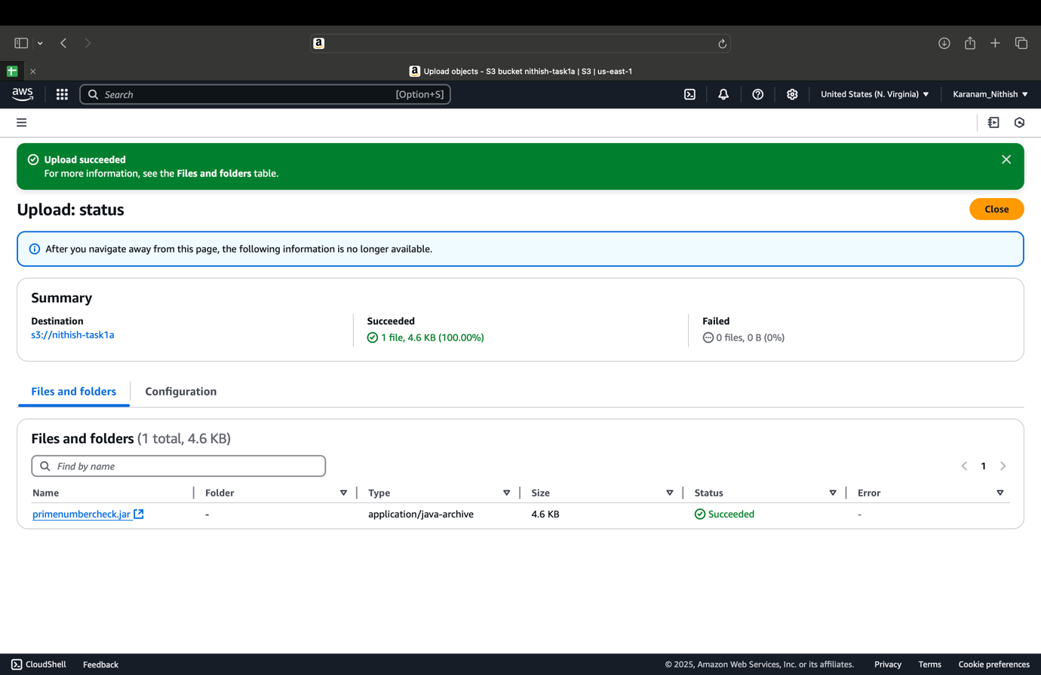  
  
  
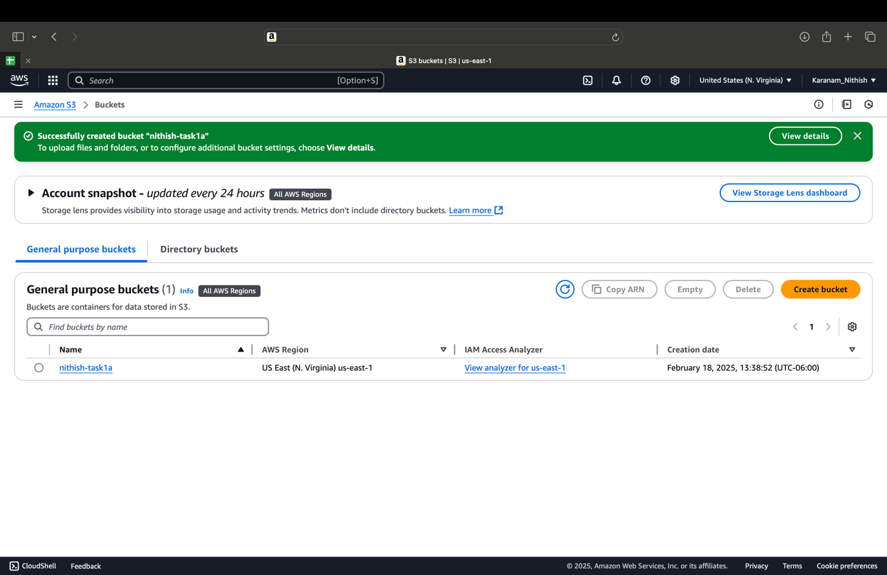  
  
  
Here i uploaded the data set in the bucket in the inputfile  
  
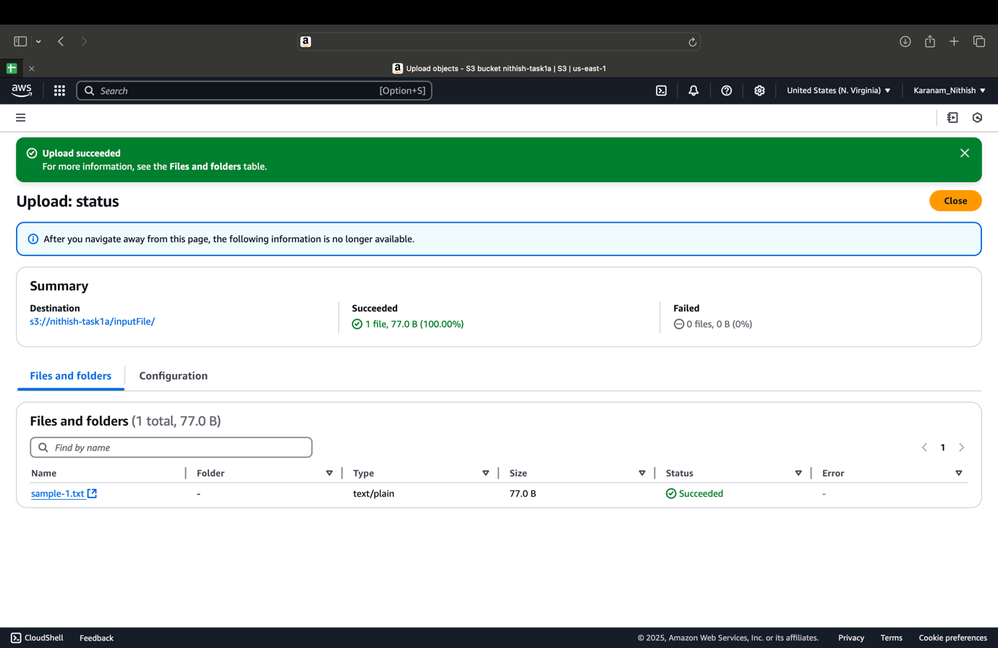  
In the bucket there are 2 folders and one is the jar file and another one is the outputfile   
  
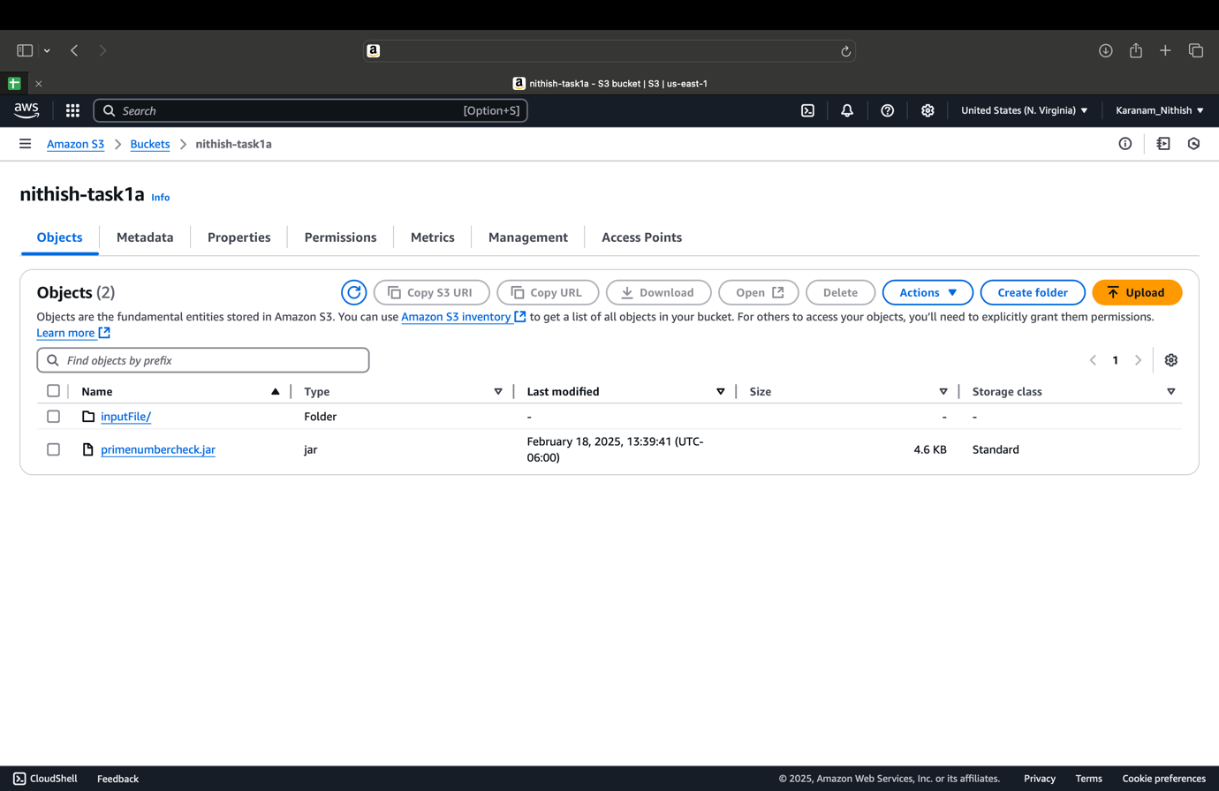  
  
  
  
  
I Created a EMR for this , which I have given name PrimeNumberCheck1, in this I added the steps and changes the location to the Public 172.31.64.0/20 us-east-1f and changed the security to the default , Now it is the initially in the starting stage and we need to wait till it reaches the Running state.  
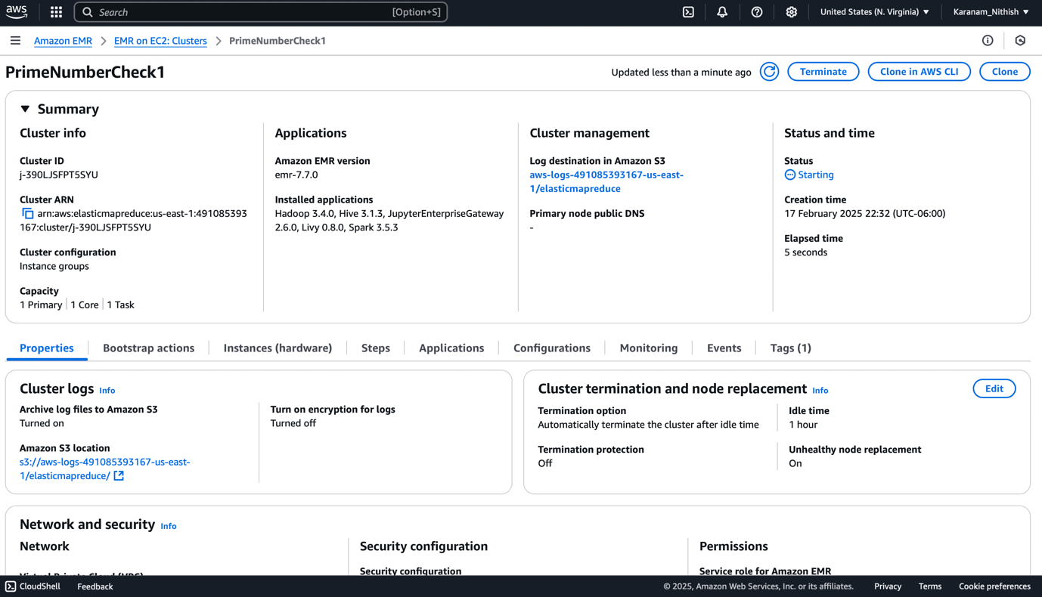  
  
  
  
Finally , after 5 min and 54 sec Elapsed time the status changes to the running status ,now we are good to run the cloud shell in the order to check the prime number   
  
  
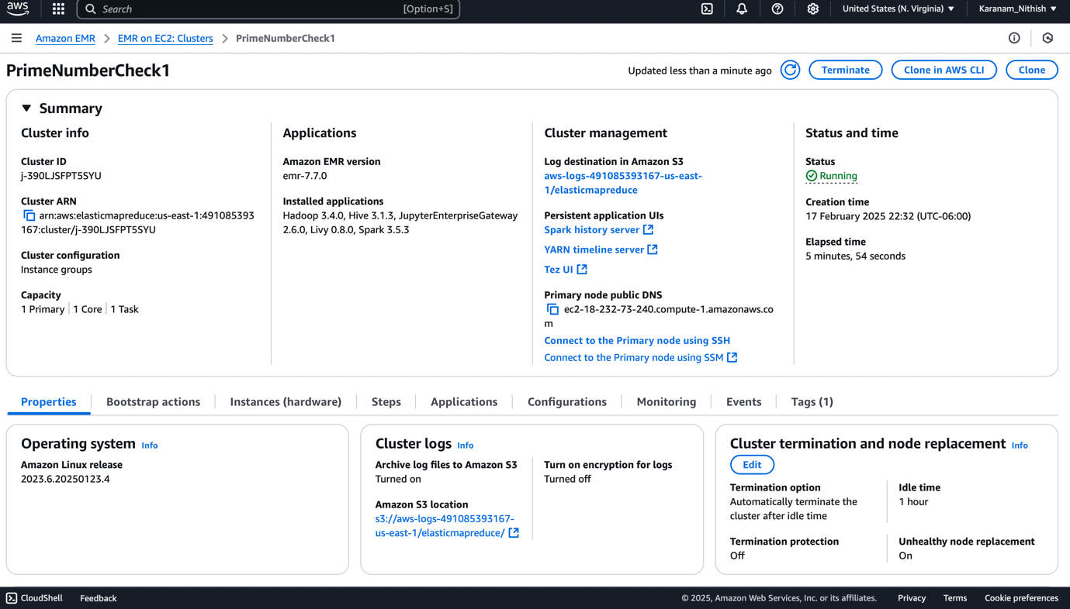  
  
I opened the cloud shell after running the output file that was generated in the Bucket where I have created the bucket . when I pasted the url in the cloud shell it is showing which numbers is prime number or not   
  
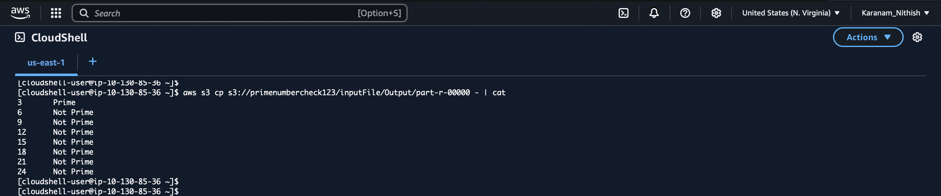  
  
  
1b.Describe the MapReduce Framework. Explain the workings of a MapReduce job with a detailed example  
  
MapReduce is a processing engine and programming model used for processing large volumes of data in a parallel and distributed way. It decomposes a job into two major tasks: the Reduce task and the Map task. In the Map stage, input data—frequently held within a distributed file system such as HDFS—is divided into chunks of independent pieces of data. Each piece of data is processed by a mapper, and each mapper produces an output in terms of a series of key-value pairs. These key-value pairs are shuffled and sorted so that all values which belong to the same key are collated. In the Reduce phase, reducers operate on these collated values to generate a summarized or aggregated output, which is then written back to HDFS.

Consider a step-by-step example based on the traditional "Word Count" problem. Suppose you have a large collection of text documents stored in HDFS and you want to count the frequency of each word across all documents. In the Map phase, each mapper reads a portion of the text, tokenizes the content into individual words, and emits a key-value pair for each word encountered—such as ("hadoop", 1) or ("mapreduce", 1). Once all mappers finish their processing, the framework performs the shuffle operation, grouping all the pairs by key so that each reducer receives a key and a list of corresponding values (for example, ("hadoop", [1, 1, 1, .])). In the Reduce phase, each reducer then sums these values to compute the total count of each word and outputs the final result, for instance, ("hadoop", 1000).

This process not only illustrates how MapReduce abstracts the complexity of parallel data processing but also shows how it efficiently leverages distributed computing resources. The framework handles fault tolerance by reassigning tasks if any node fails, ensuring robust execution. Additionally, the intermediate shuffle phase is optimized to reduce network congestion by sorting and grouping data close to where it is stored. In general, MapReduce is still a core paradigm for big data processing that enables developers to write fault-tolerant and scalable applications to execute on big clusters of commodity hardware.  
Core Components of MapReduce

Job Client:

This is the application or user submitting the job. The job client splits the input data and sends the job configuration (the code for Map and Reduce functions, input and output paths, etc.) to the JobTracker (in older Hadoop versions) or ResourceManager (in YARN-based systems).

TaskTracker / NodeManager:

Worker nodes in the cluster that execute the tasks assigned by the master. Each node runs one or more tasks (Map or Reduce) concurrently. They report progress and status back to the master.

Map Function:

Input: A split of the overall input data.

Process: Each mapper reads its data split, usually line by line or record by record. It performs user-defined processing to convert each record into a collection of intermediate key-value pairs.

Output: Intermediate key-value pairs partitioned and sorted by key.

Shuffle and Sort:

Between the Map and Reduce phases, the framework automatically redistributes data based on keys. This shuffle phase groups all occurrences of the same key across the entire dataset together, ensuring that each reducer receives all the data it needs to process a given key.

Reduce Function:

Input: A key and a list of associated values.

Process: The reducer aggregates or transforms these values, performing tasks like summing, averaging, or concatenating them.

The final output is stored in the output file, typically back to HDFS.

Output Collector:

Each reducer outputs its results to the distributed file system. The output is partitioned according to the keys handled by each reducer, creating the final output of the job.

1b. Design a program to check whether a number is Perfect number or not using AWS and provide detailed explanation  
  
I created a bucket name nithishtask1b in amazon S3 in order to upload the files   
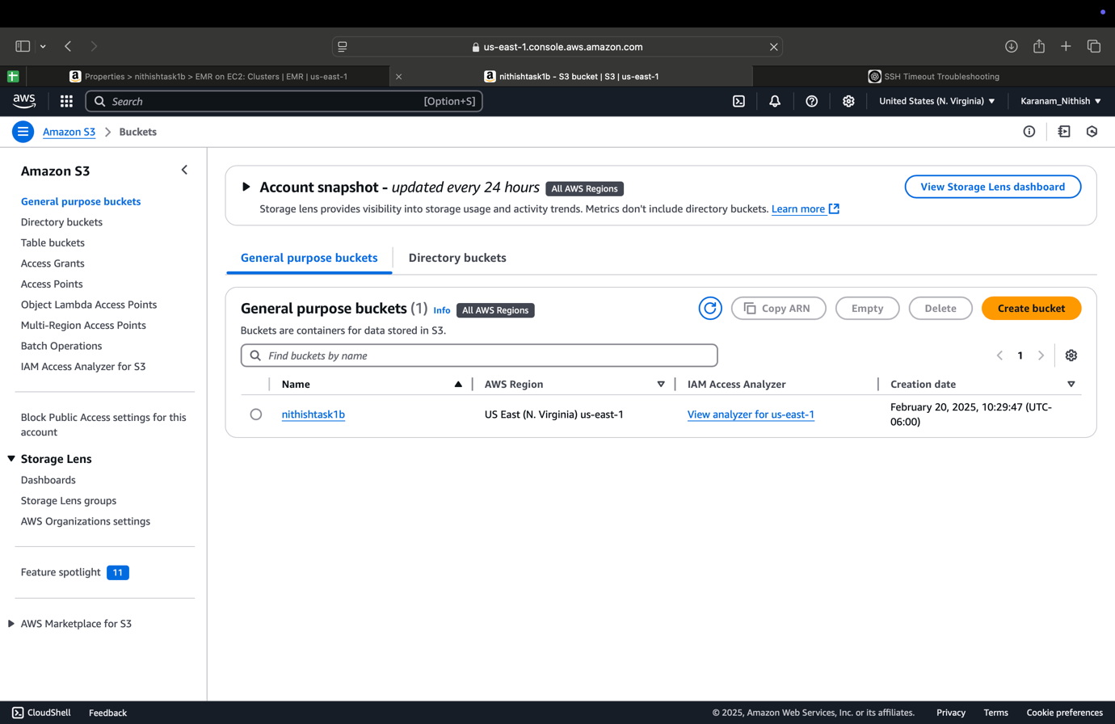  
  
In that nithishtask1b bucket I Uploaded the perfectnumber jar file in the S3 bucket and created the folder in which I have uploaded the sample file   
  
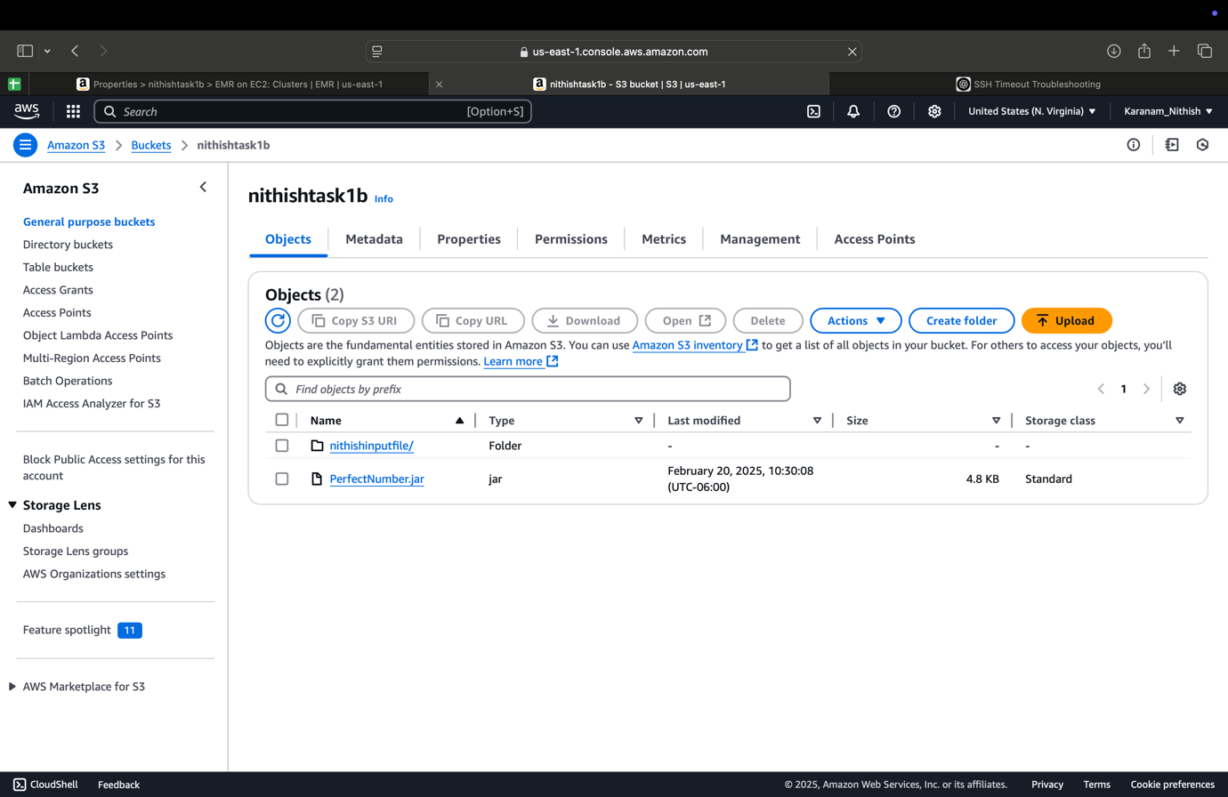  
I uploaded the sample .txt file to the nithishinputfile which I have created the folder   
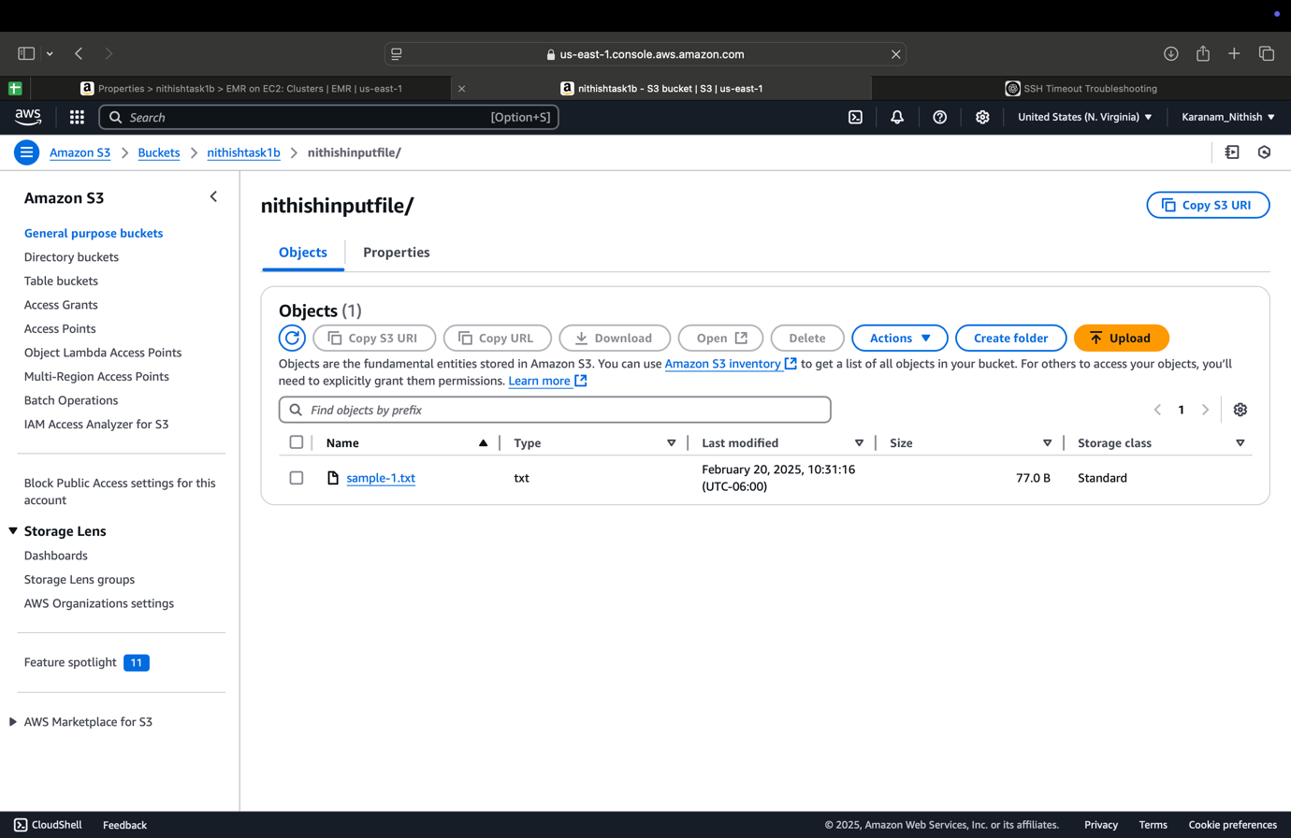  
  
  
This is the perfectNumber.jar file   
  
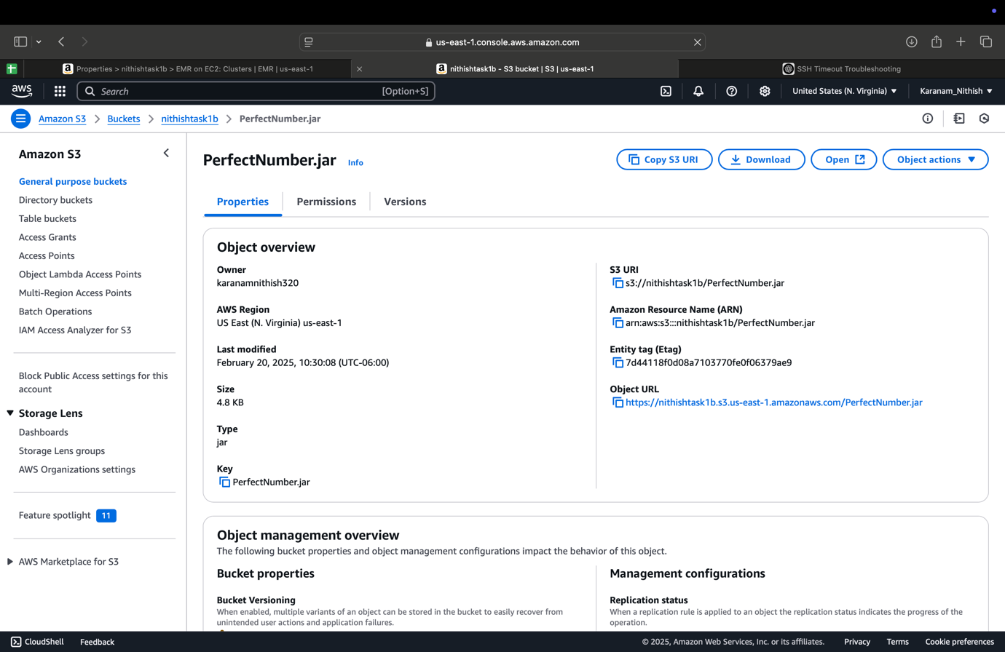  
  
  
  
After creating the bucket and uploaded the files in it , now I have created the EMR and the name I have given is the nithishtask1b and now it is currently in the Running state and we need to wait for the status to be running .  
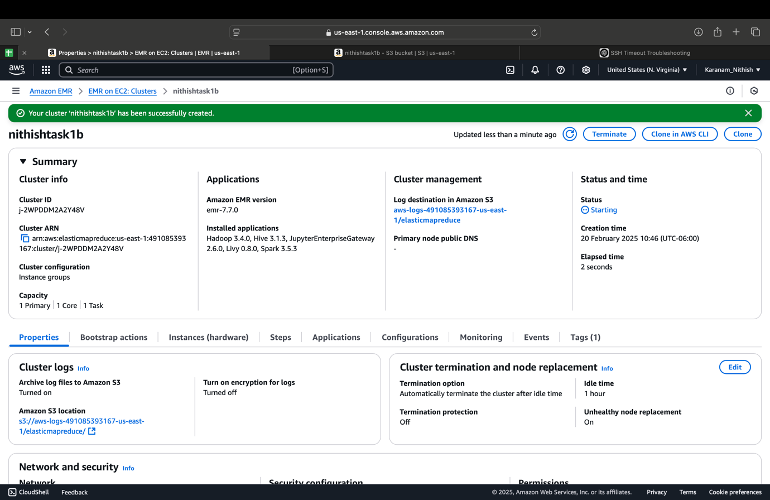  
  
Now the status changed to the Running that the Steps are correctly executed without any mistake .  
  
  
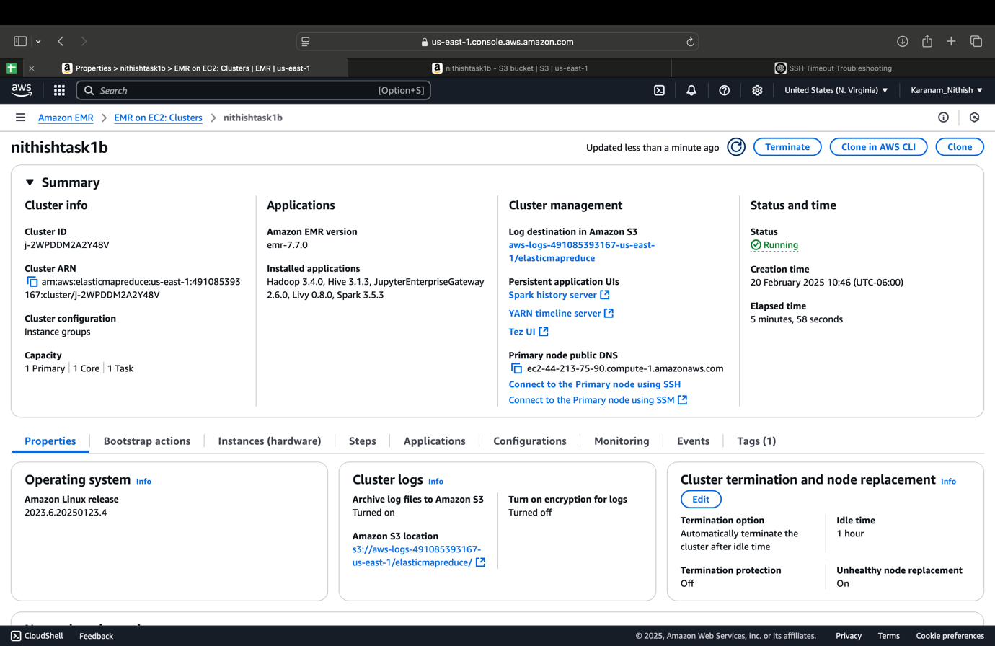  
After successfully creating the EMR we can see that the nithishoutputfile/ in the S3 bucket in the nithishtask1b folder .  
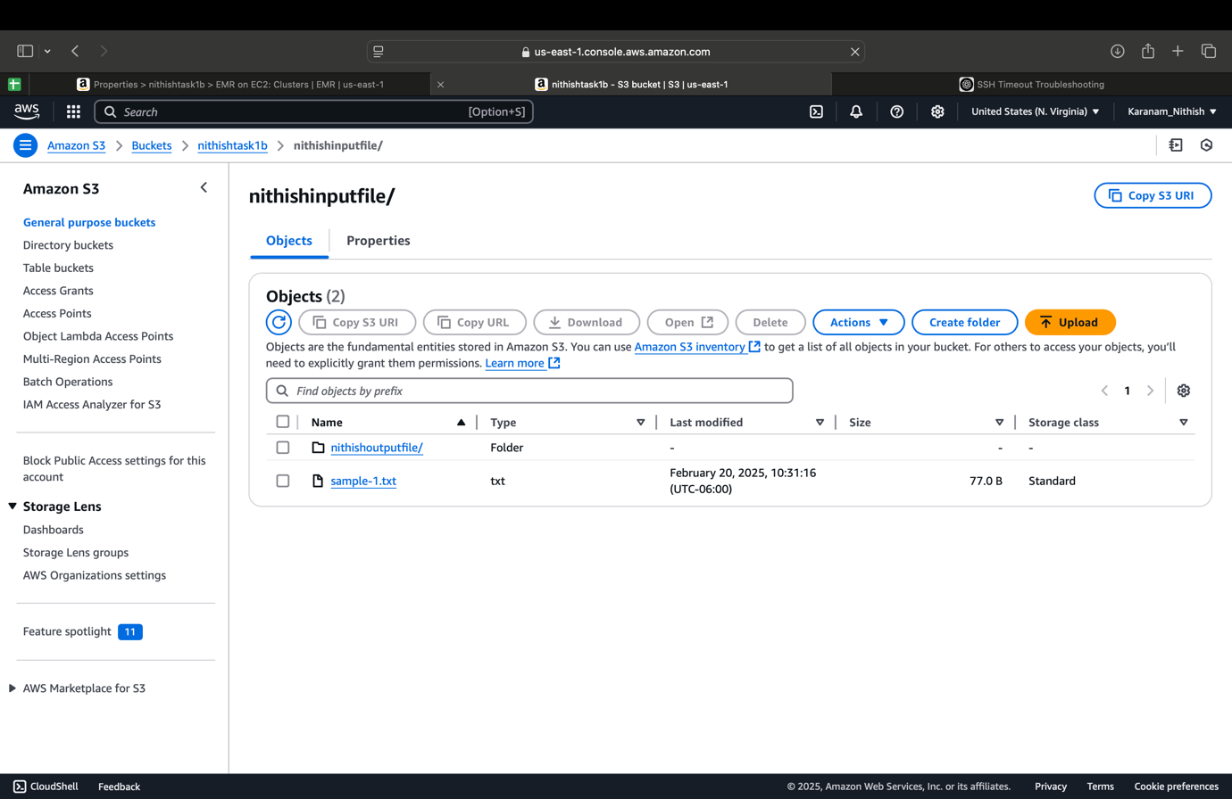  
  
we can see that the EMR is successfully executed and folder is created

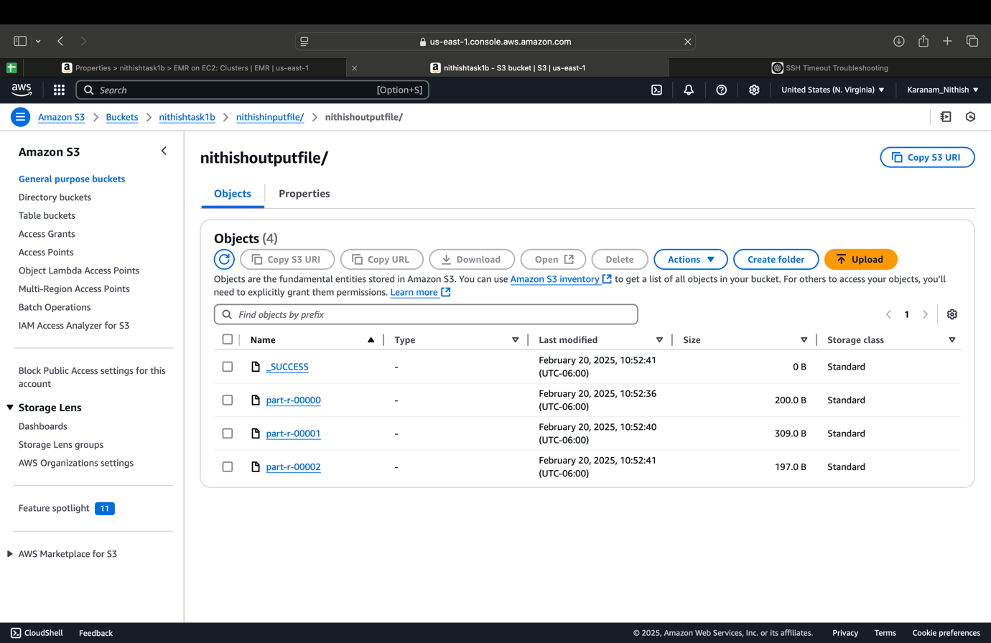

Now we need to copy the URL address of all the part-r- that were generated in the bucket and copy their Url address of ip nodes and now open the cloudshell and paste the URL in their and run , I have did that for all the three generated folders in the bucket .

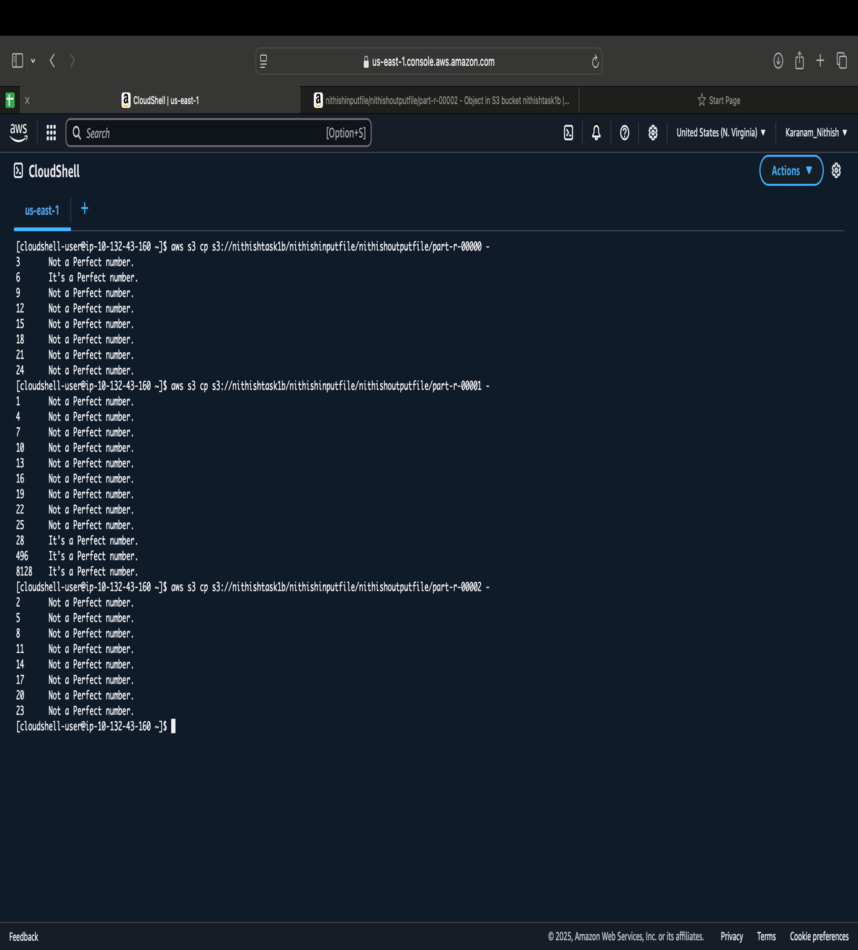

Task 2 – Hive

Task 2A

1A. Hive is an Hadoop-based data warehousing tool that supports querying and managing large data with a SQL-like language, HiveQL. Its architecture conceals Hadoop's MapReduce framework complexity, enabling users to analyze data without the need to write low-level code.

At the core of Hive is the Hive Driver, which is the query processor coordinator. Upon invoking a query, the Driver passes it to the Compiler, which inspects and validates the query, after which an execution plan is developed. The query is optimized by the Compiler through the translation of HiveQL into one or more MapReduce jobs or other execution engines like Tez or Spark, depending on the configuration.

The Hive MetaStore is a significant module that serves as a central repository of metadata. It stores the data related to the database schema, table definition, partition information, and data location. This metadata enables Hive to understand the structure of the data residing in HDFS and finally optimize query execution without scanning complete data sets.

Once the execution plan is prepared, the Driver sends it to the Executor, which runs the plan on the Hadoop cluster. The Executor manages the execution of MapReduce jobs (or tasks on the chosen engine) and governs their life cycle, monitoring progress and recovery from failures.

Together, these pieces allow Hive to transform complex data processing into SQL queries that are actionable, thereby providing robust data warehousing capability on top of Hadoop's scalable storage and distributed processing capability.  
  
Apache Hive is a data warehousing and SQL-like query language built on top of Hadoop with the goal of making it simple to conduct data analysis of large datasets stored in HDFS. It hides the complexity of the underlying distributed computing infrastructures so that one can think in terms of HiveQL queries instead of MapReduce code.

At the center of the core architecture of Hive is the Driver, which acts as the query-processing central coordinator. After a HiveQL query is entered by a user, it is received by the Driver and passed on to the Compiler. The Compiler first parses and validates the query against the schema information available in the Hive MetaStore—a metadata store containing information such as table definitions, schemas, partition information, and data locations. This metadata repository is required since it allows Hive to learn about query optimization and data structure without reading the entire dataset.

Once the query is parsed, the Compiler produces an optimized plan for execution, which typically maps the abstract HiveQL into one or more MapReduce, Tez, or Spark jobs depending on cluster settings. The plan is then sent back to the Driver, which manages the life cycle of the query.

2A. Perform the tasks using Hive in AWS and provide detailed explanation  
  
I crated a Bucket named nithishtask2 , in that I uploaded the three files that were given movies, ratings and users   
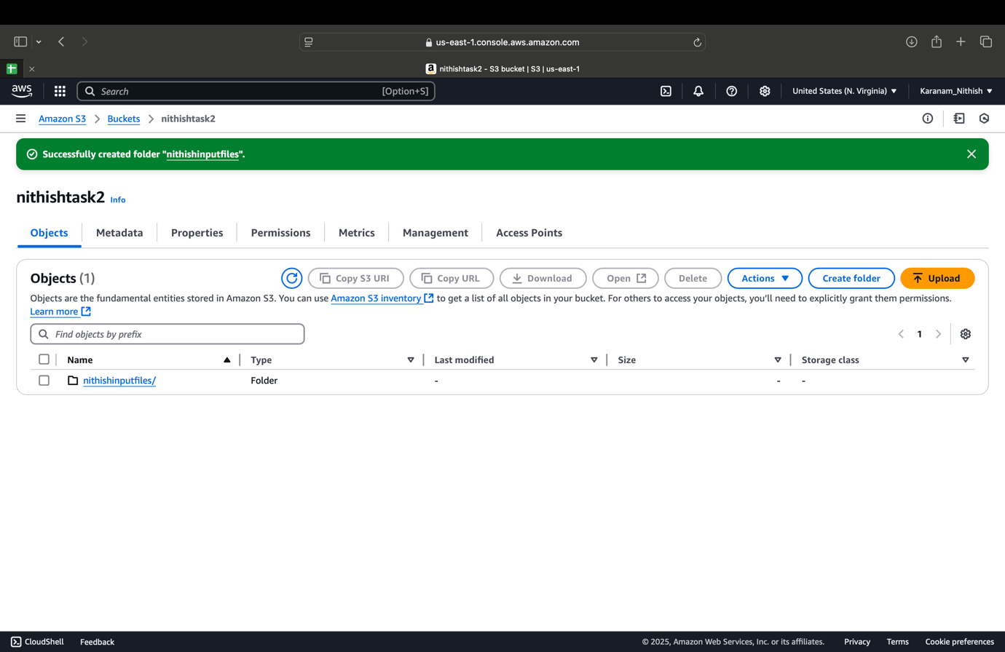  
  
here are the files present in the bucket , that I have uploaded   
  
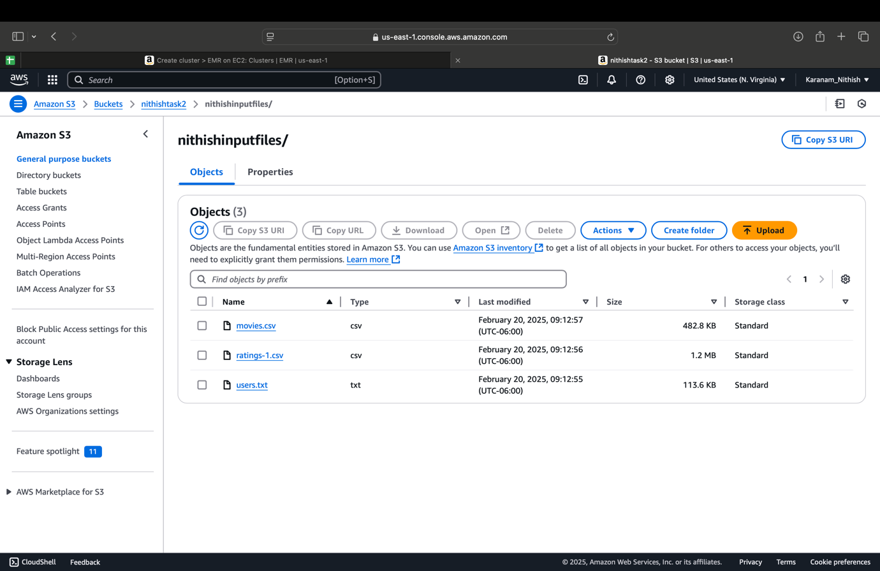

After completing the creating the bucket ,now I created the EMR using the name nithishtask2

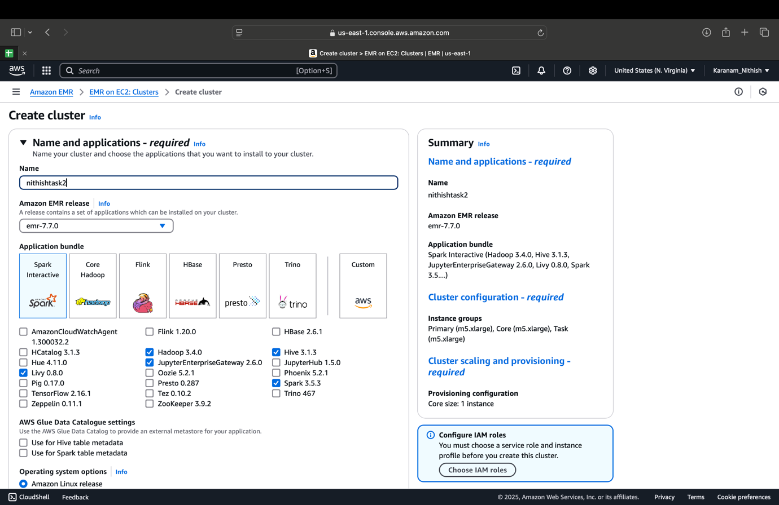  
  
after creating the cluster it will initially under starting stage for some time we need to wait for some time to go in to the waiting state   
  
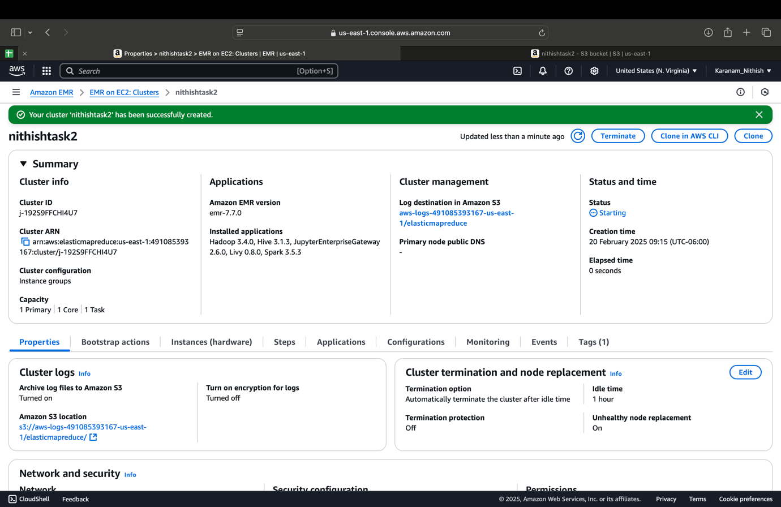  
  
  
  
  
when the state changed in to the waiting status now we need to make sure that we have the ssh inbound rules are present in the secdurity   
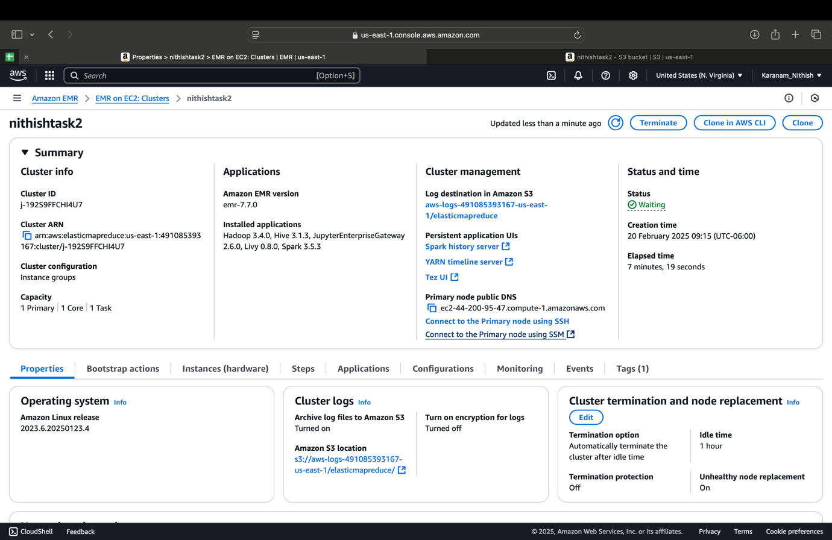  
  
after that open the terminal and enter command cd Downloads to change the directory to the downloads and after I entered command ssh -i nithishtask2b.pem [hadoop@ec2-44-200-95-47.compute-1.amazon.com](mailto:hadoop@ec2-44-200-95-47.compute-1.amazon.com) and entered yes , now it changes to Hadoop .  
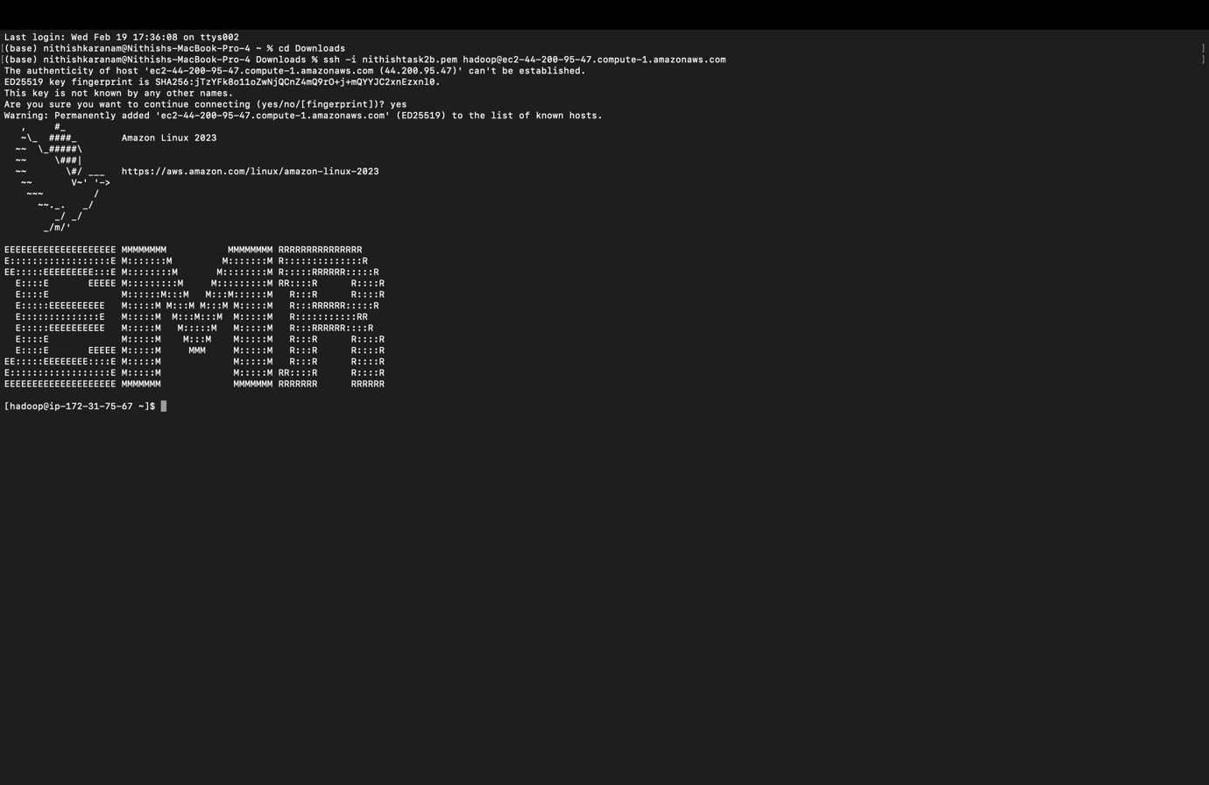  
  
  
now we change to hive by giving command Hive and now it changed too hive state and I created the table for every file like movies , rating and users and loaded the data in the tables and obtained the data successfully and select * from table_name to view the data present .  
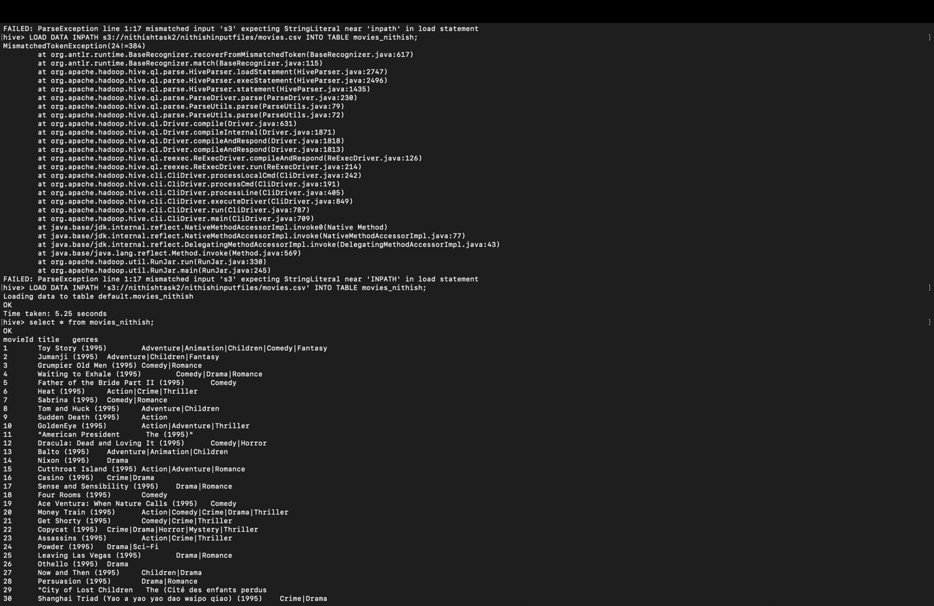  
CREATE TABLE movies_nithish ( movieId STRING, title STRING, genres STRING ) ROW FORMAT DELIMITED FIELDS TERMINATED BY ',' STORED AS TEXTFILE;  
To load the data in the table   
LOAD DATA INPATH 's3://nithishtask2a/nithishtask2a/movies.csv' INTO TABLE movies_nithish;  
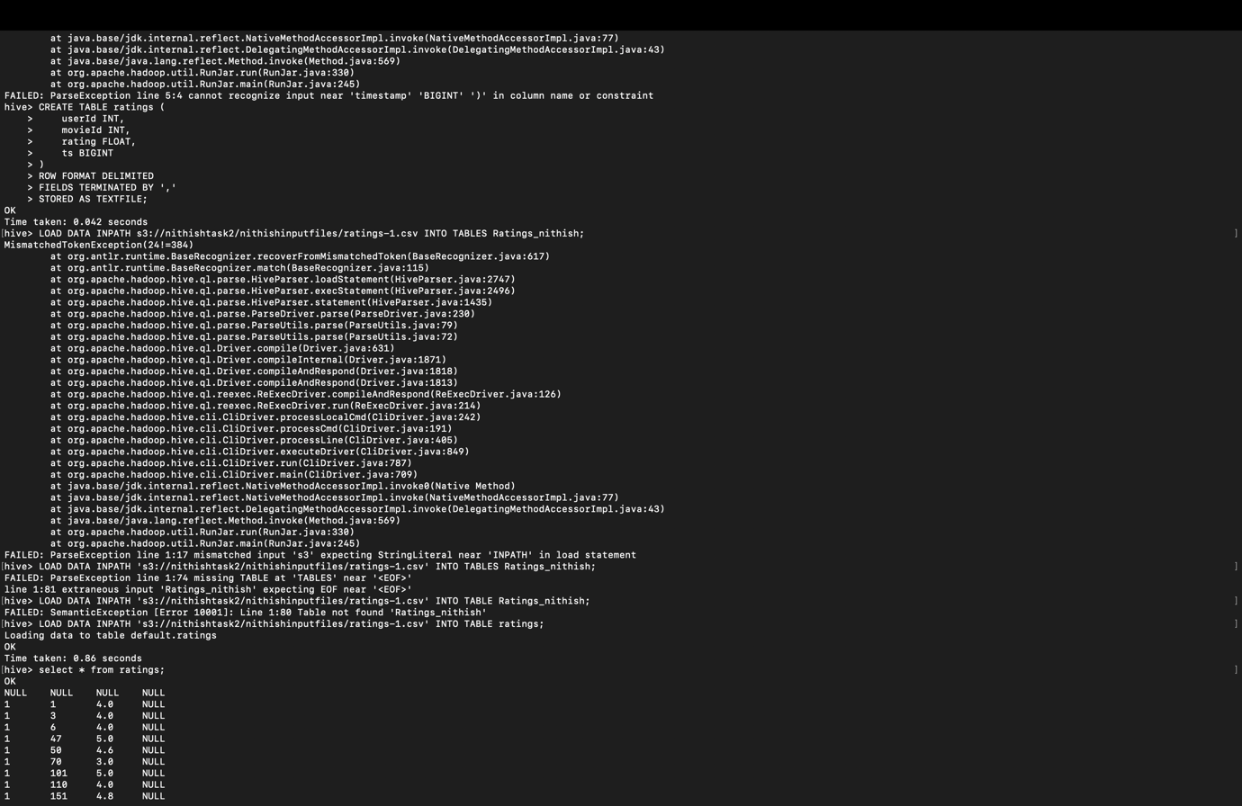

-- Create the movies_nithish table

CREATE TABLE movies_nithish (

movieId STRING,

title STRING,

genres STRING

)

ROW FORMAT DELIMITED

FIELDS TERMINATED BY ','

STORED AS TEXTFILE;

-- Load data from S3 into the table

LOAD DATA INPATH 's3://nithishtask2a/nithishtask2a/movies.csv' INTO TABLE movies_nithish;  
  
  
  
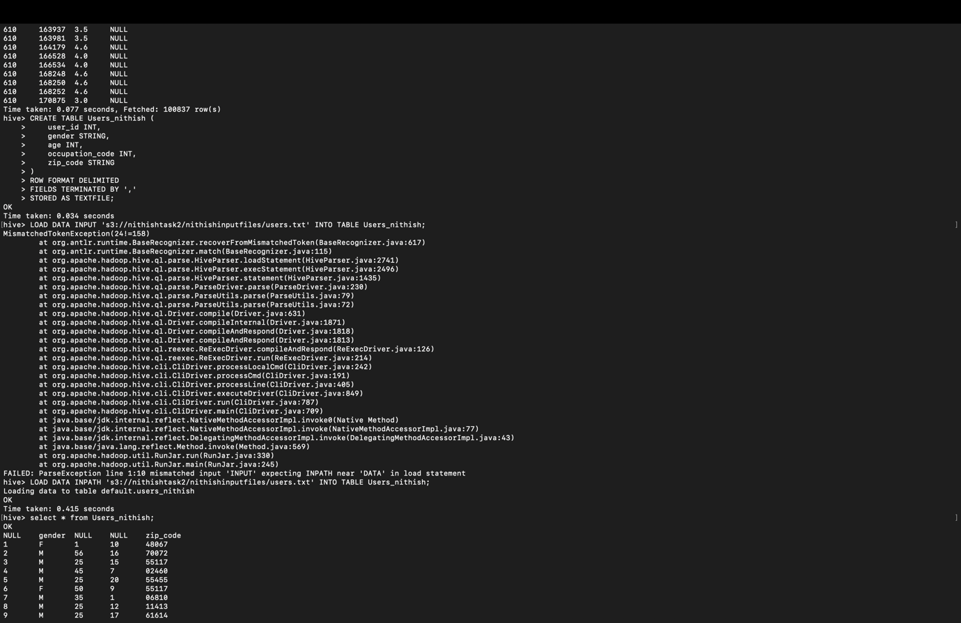

-- Create the Ratings table

CREATE TABLE ratings (

userId INT,

movieId INT,

rating FLOAT

)

ROW FORMAT DELIMITED

FIELDS TERMINATED BY ','

STORED AS TEXTFILE;  
  
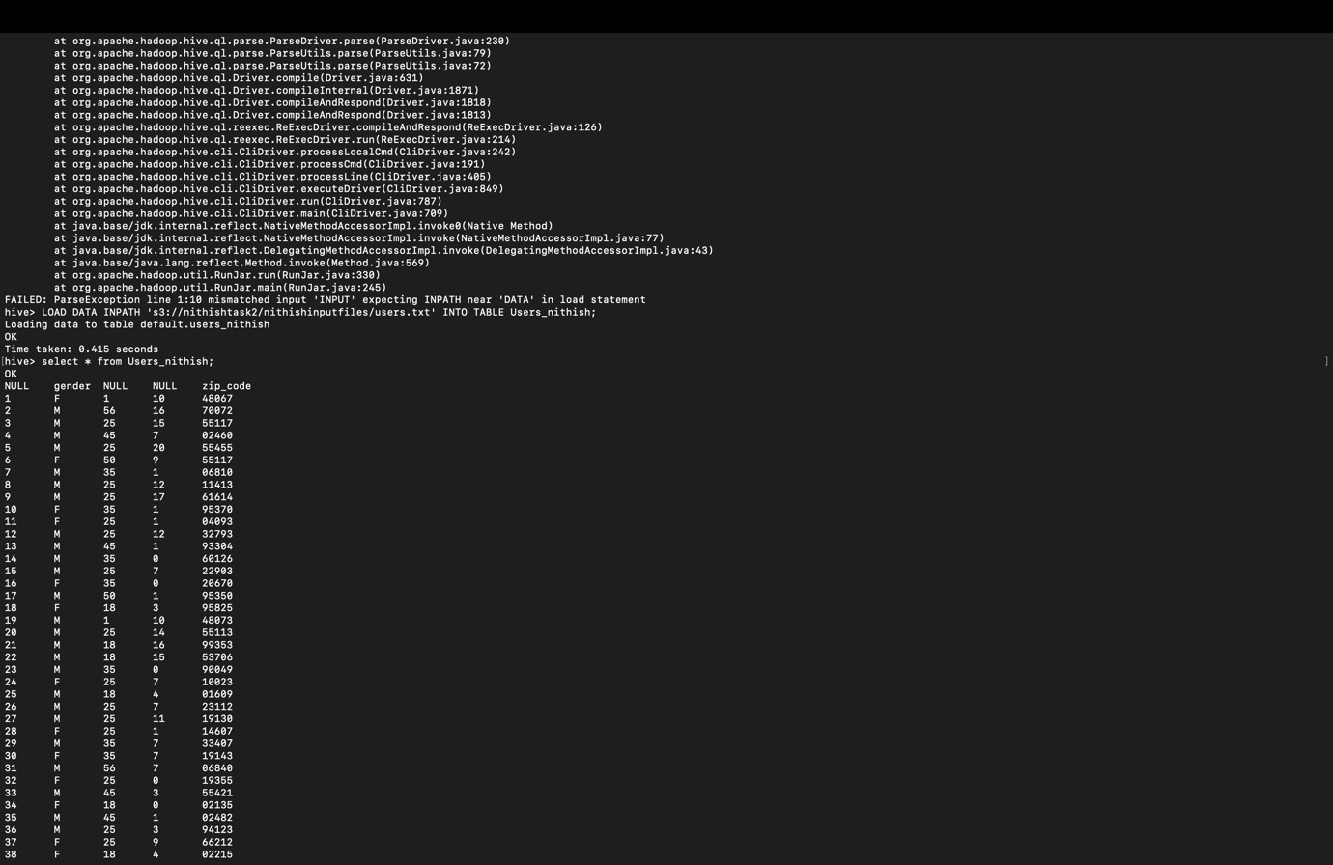  
  
2. For movies table: List all movies with genre of movie is “Fantasy” and “Adventure  
select moviesId,title ,genres from movies_nithish where genres like ‘Fantasy’ and genres like ‘Adventure’  
I used this command to obtain the list , in the below screen short it is present   
  
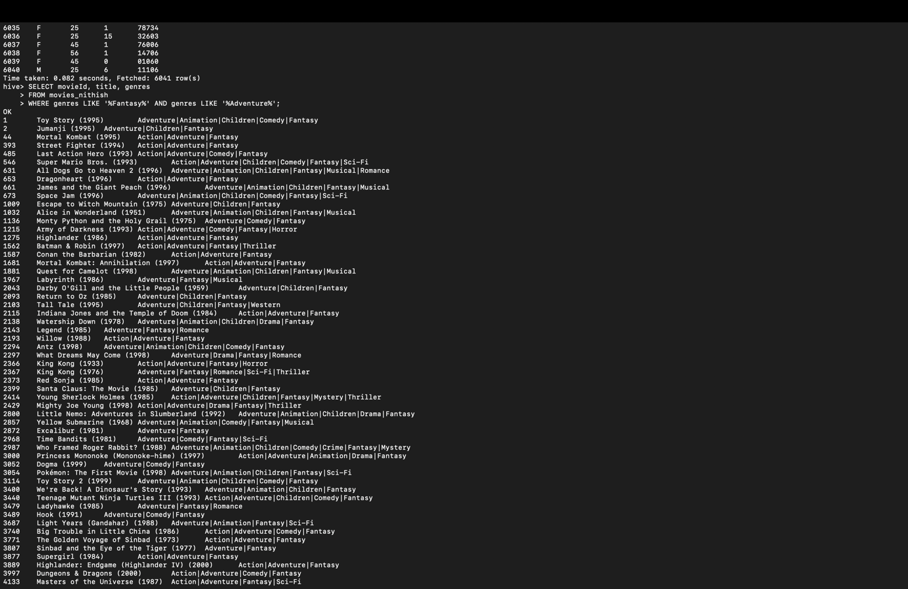  
  
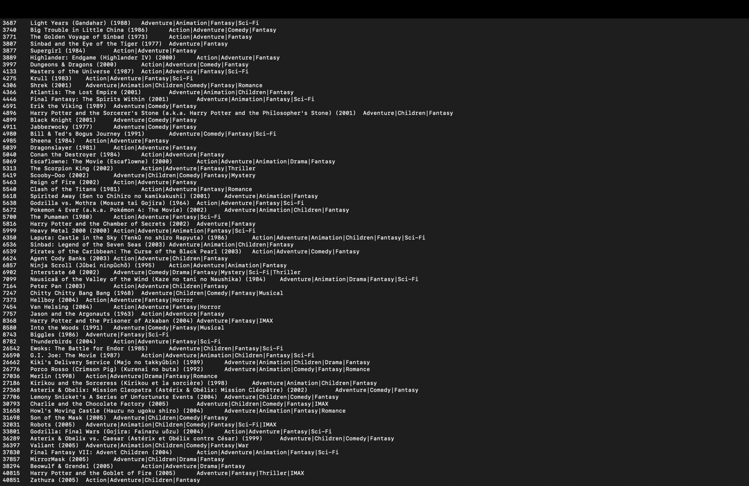  
  
  
3. For Ratings table:List movie ids of all movies with rating equal to 4  
select movieId from Ratings where rating = 4; and obtained the results and where present in the below screenshorts

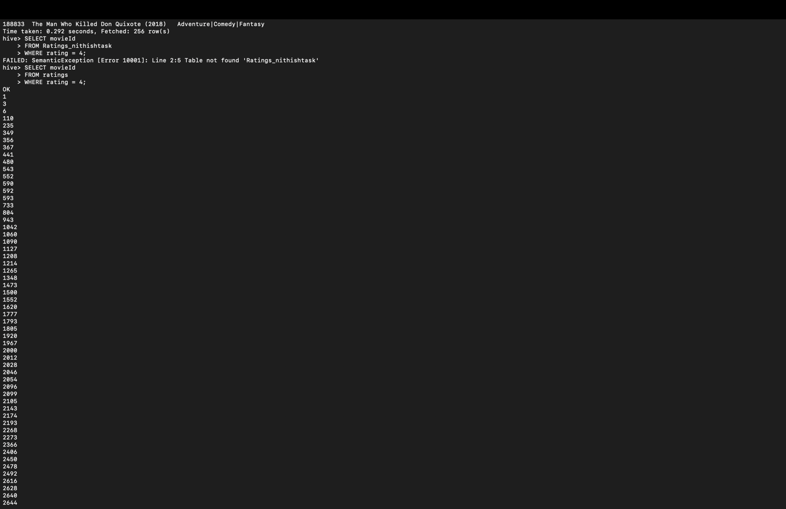  
  
  
  
4. Find top 10 highly rated "Comedy" movies with descending order of rating  
SELECT m.movieId, m.title, AVG(r.rating) AS avg_rating  
FROM movies_nithish m  
JOIN Ratings_nithishtask r  
ON m.movieId = r.movieId  
WHERE array_contains(split(m.genres, ','), 'Comedy')  
GROUP BY m.movieId, m.title  
ORDER BY avg_rating DESC  
LIMIT 10;  
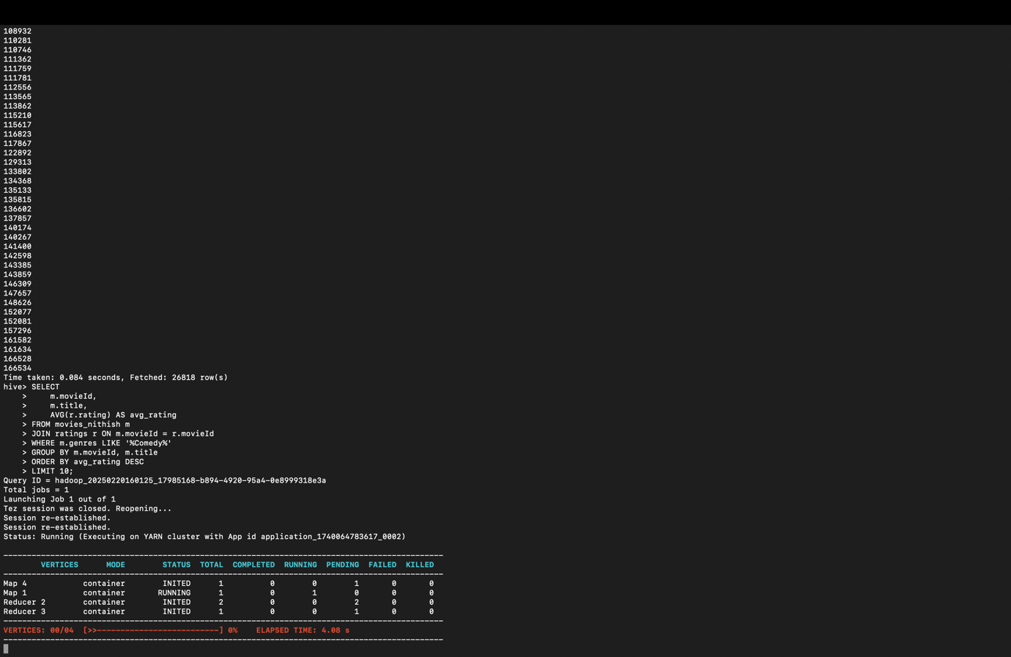  
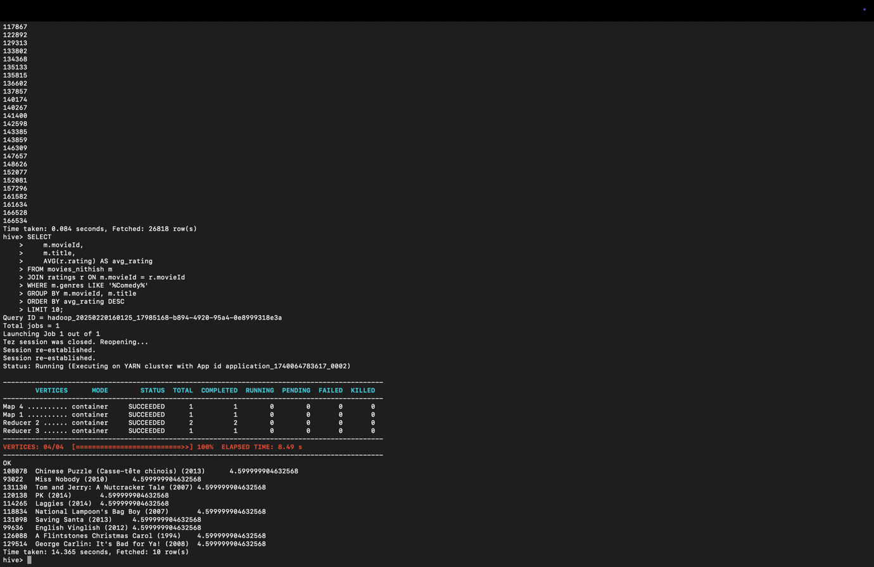  
  
Task 2b:  
Discuss the significance and differences between ORDER BY, CLUSTER BY,SORT BY and DISTRIBUTE BY clauses in HiveQL with examples. Implement anyone query using the given datasets and display the output.  
  
ORDER BY  
This operation makes one reducer sort all the records in the final result. Since it guarantees that the output is globally sorted, it can be a performance bottleneck on very large datasets, since all the data passes through a single node. For instance, using ORDER BY ensures the entire result set is strictly in order.

SORT BY  
SORT BY sorts data for every reducer separately. That is, the output of every reducer is sorted but the final output may not be globally ordered for all reducers. SORT BY is scalable over ORDER BY since it employs multiple reducers, which is helpful when handling large datasets if a global sort is not required.

DISTRIBUTE BY  
This directive specifies the distribution of rows to reducers. It makes sure that all rows with the same column value go to the same reducer. DISTRIBUTE BY splits data between reducers but doesn't sort the data. This is especially useful if you would like to perform subsequent operations (like aggregations) on data by some key.

CLUSTER BY  
CLUSTER BY is a shortened syntax that encompasses the operations of DISTRIBUTE BY and SORT BY on the same column. It distributes data so that all records of the same column value go to one reducer, and it sorts data within each reducer. It localizes partitions to be sorted, which is beneficial for most downstream operations. It does not produce a globally sorted output, however.  
Example Query  
Let's say you have a table named movies_nithish with columns movieId, title, and genres. If you must partition the data by genre and sort each partition by movie title, you can use the CLUSTER BY clause. Here's an example query:

SELECT movieId, title, genres FROM movies_nithish CLUSTER BY genres;

Explanation of the Query:

CLUSTER BY genres

This instructs Hive to send all the rows with the same genre value to the same reducer. Within that reducer, the data will be sorted based on the genres column. This does not necessarily ensure an entire global order across all data, but it does ensure each partition is sorted by genre.

When you run this query, its output will be divided between multiple reducers. All output from each reducer will be sorted by genre, and all rows for the same genre will be consecutive to one another. This might improve performance where local ordering is acceptable and will avoid the overhead of a full global sort that ORDER BY requires.

2b.4. Perform the tasks using Hive in AWS and provide detailed explanation  
a. Print the age and total count of ratings given by the userId 100  
SELECT u.age, COUNT(r.rating) AS total_ratings FROM Users_nithish u JOIN Ratings_nithishtask r ON u.user_id = r.userId WHERE u.user_id = 100 GROUP BY u.age;  
  
This question joins the Ratings_nithishtask table and the Users_nithish table on matching user IDs to gather data about user 100. It filters the records via the WHERE clause so that the data will take into account only the details of user 100. And then groups the results by the age of the user, finding the sum total of the ratings provided by that specific user, using the COUNT function as an aggregate over ratings. Essentially, the query not only retrieves the age of user 100 from the Users_nithish table but also calculates how many ratings they've issued by tallying up the applicable entries in the Ratings_nithishtask table, showing both pieces of information side by side.  
  
Below are the Screen shorts present   
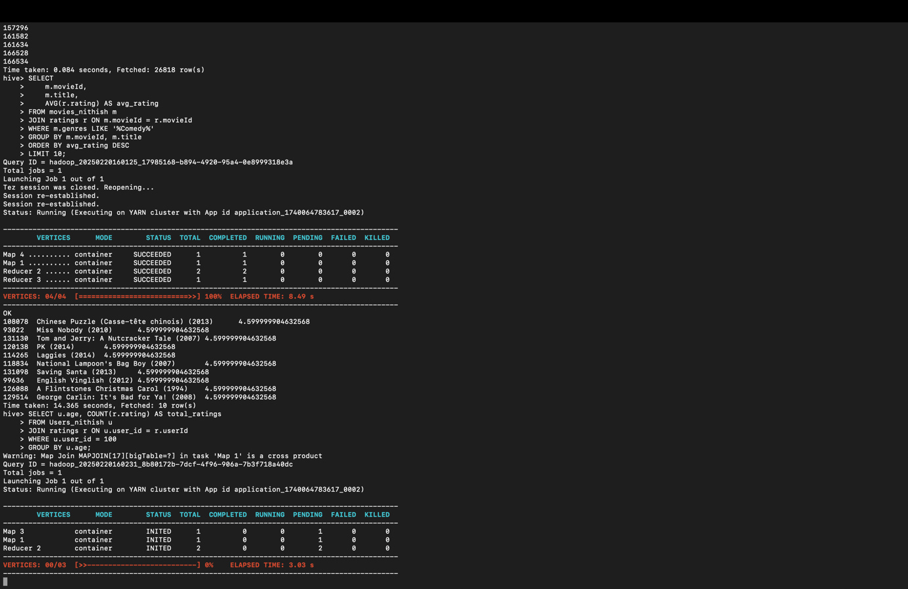  
  
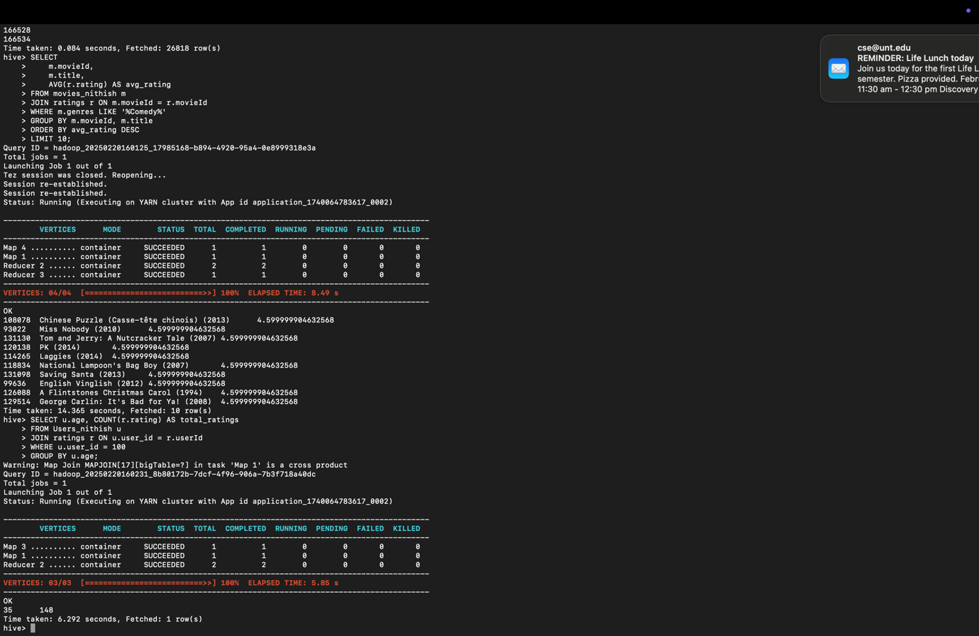

2. List the count of ratings for each distinct userId  
SELECT userId, COUNT(*) AS rating_count FROM Ratings_nithishtask GROUP BY userId;  
This request divides all the records in the Ratings_nithishtask table by the userId field, counts the number of records (i.e., ratings) for each distinct userId, and returns a list of user IDs and their corresponding rating counts.  
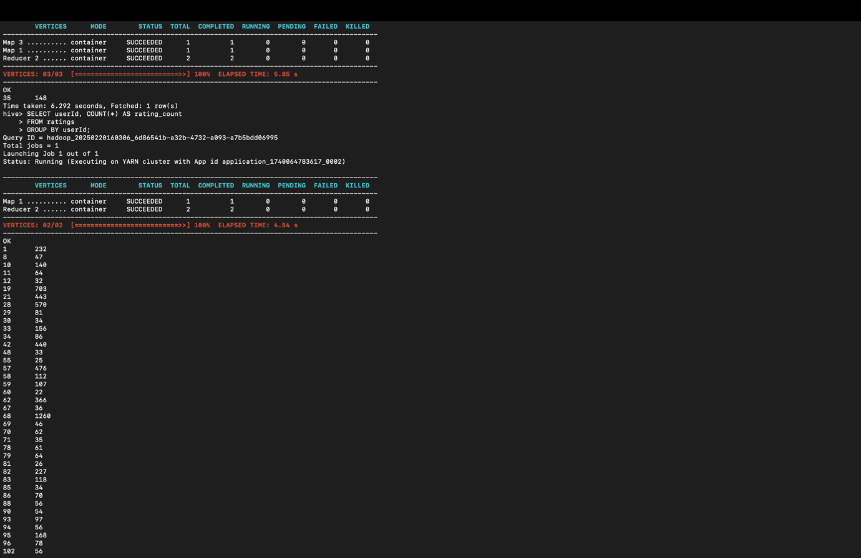  
  
  
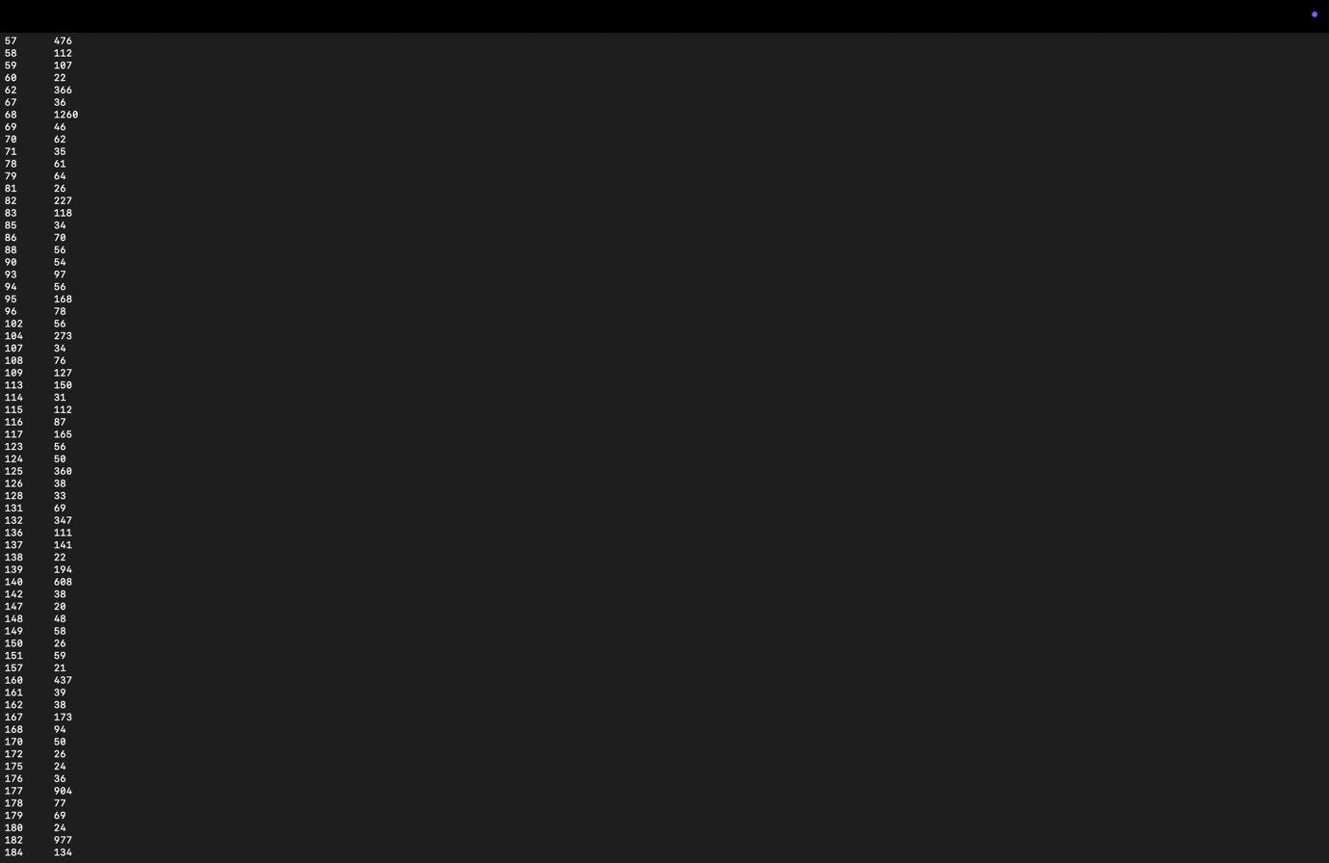  
3.List top 10 movieId and titles with highest rating in the descending order  
SELECT m.movieId, m.title, AVG(r.rating) AS avg_rating FROM movies_nithish m JOIN Ratings_nithishtask r ON m.movieId = r.movieId GROUP BY m.movieId, m.title ORDER BY avg_rating DESC LIMIT 10;  
  
In this query, we inner join the ratings table and the movies table on the common movieId, calculate the average rating per film, group by title and movieId, and order the results in descending order by the computed average rating. We then restrict the result to the first 10 records.  
  
  
  
4.Find the top 3 popular genre movies w.r.t total numbers of ratings received. Sort the genres in the descending order. Print the genre and the count of ratings in the output.  
  
SELECT genre, COUNT(*) AS rating_count FROM movies_nithish m LATERAL VIEW explode(split(m.genres, ',')) movies AS genre JOIN Ratings_nithishtask r ON m.movieId = r.movieId GROUP BY genre ORDER BY rating_count DESC LIMIT 3;  
  
In this query, the LATERAL VIEW with explode(split(m.genres, ',')) creates a new row for each genre in the comma-separated list for every movie. The JOIN then links each movie (and its individual genres) with its corresponding ratings. Finally, grouping by genre and counting the records gives us the total number of ratings per genre, which is sorted in descending order and limited to the top 3.  
